**Day 5.1 – Web Hosting**

Two common web hosting service providers are “GoDaddy” and “SquareSpace”. Complete the table below to compare these services and to learn more about web hosting.

1. Resources to learn about web hosting providers are as follows:
   1. SquareSpace – www.squarespace.com
   2. GoDaddy - ca.godaddy.com
2. Complete the following table.

|  |  |  |
| --- | --- | --- |
| Topic | SquareSpace | GoDaddy |
| Website Hosting   * Template Based Web Design * Survey tools and other applications * Internationalization * Professional Design Service * Website Analytics * Backup & Restore | Their award-winning templates are the most beautiful way to present your ideas online. Stand out with a professional website, portfolio, or online store. Present your work using Squarespace’s professional portfolio designs. Display projects in customizable galleries and add password-protected pages to share private work with clients. Learn where your website traffic is coming from, what your visitors are looking for, and how they’re interacting with your content or products through our in-depth Analytics tools. | For professional uses  Four hosting plans  Once you purchase a Web hosting plan, GoDaddy stores your site on one of their servers and assigns it a unique DNS. The DNS serves as the address that allows people around the world to find and view your website. This unique address is required in order for people to view your site.  ·They support Windows and Linux hosting |
| E-Commece   * On-Line Store Support * Check-Out Cart Management * Credit Card Payment Processing * SSL Certificates | Think of Squarespace as your very own IT department, with free, unlimited hosting, top-of-the-line security, an enterprise-grade infrastructure, and around-the-clock support. Get personalized support from our Customer Care Team via email or live chat, or join a live webinar. Reach out any time — they’re here 24/7. | An SSL Certificate protects the data going to and from you site — from personal info to credit card numbers — making it impossible for hackers to read them. And when visitors feel safe, they’re more likely to give you their business. |
| Professional Email   * Domain Name Registration * Domain Name Transfer * DNS (Name Service) * Web Mail * IMAP / POP3 Support | Buying a domain with Squarespace is simple and straightforward. There are no hidden fees, price hikes, or ads. All Squarespace sites on an annual plan include one custom domain, free for its first year. Additional domains are between $20 and $70 per year. Yes. If you registered a domain through Squarespace and want to use it with a different Squarespace site, you can move it from your Domains panel. If you delete your Squarespace site, you'll have the option to let your domain expire, renew it for an annual fee, or transfer to a new provider. If you renew, you'll continue to manage the domain through Squarespace. If you’ve already got a domain from a third-party provider, you can simply transfer it to Squarespace. | Everyone has email, but that doesn’t mean all email is the same. Customers are nine times more likely to choose a business with a professional address like you@ludlow.biz.  ·They give people the choice to create emails from the site |
| Other Services   * Blogging * Cloud File Storage * Media Streaming | Take advantage of their powerful blogging tools to share your story, post company news, or announce a product release. Categorize, share, and schedule your posts to make your content work for you. | If you’ve built your website in a HTML editor, like Dreamweaver or Microsoft Expression Studio, you have to upload your website files via FTP (File Transfer Protocol). We have a built-in FTP File Manager that you can access in their Hosting Control Center  Moving your website to GoDaddy is a simple process. If you have access to your existing website files, you can upload them through our Hosting Control Center or via an FTP client. If you don’t have a current copy of your website, you should be able to request one from your current website hosting provider. |

**Day 5.2 – Internet Service Provider (ISP)**

Internet Service Providers (ISPs) provide hardware and software services to connect your LAN (in your house or your business) to the Internet.

Two most popular ISPs in Ontario are Bell and Rogers, but there are other choices.

Select an alternative ISP that operates in Southern Ontario to answer the following questions. Suggestions are:

* Primus - <https://primus.ca/>
* ExecuLink - <https://www.execulink.ca/>
* Xplorenet - <https://get.xplornet.com/>
* Start.ca - <https://www.start.ca/>

1. **What residential (i.e. home) service packages do they provide?**
   1. **Bandwidth Speed (both upload & download)**
   * Speeds up to 30 Mbps/sec (Fast internet)
   * Speeds up to 150 Mbps/sec (Faster internet)
   * Speeds starting at 250 Mbps/sec (Fastest internet)
   1. **Data Limits (and cost for exceeding limits)**

You will receive notifications when you are approaching your Mobility data limit, but if you do exceed your data limit a charge of $0.25/MB applies.

* 1. **Connection Technologies (e.g. cable, WiFi, DSL, etc.)**

Though the internet services we offer vary depending on your postal code, we are quite consistent, and we remain above the grade. Over the years, the internet and its technological counterparts, such as TV, home phones, and mobility, have become synonymous needs. With this understanding, we have evolved to offer these services and have been doing so for over 114 years

**MORE INFO:**

**Fast Internet**

* Speeds up to 30 Mbps
* An economical option best suited for light surfing & streaming, checking email and social media.
* Unlimited Usage
* Zero contracts
* 24/7 technical support

**Faster Internet**

* Speeds up to 150 Mbps
* Great for streaming videos, downloading music & movies, and online gaming with friends.
* Unlimited Usage
* Zero contracts
* 24/7 technical support

**Fastest Internet**

* Speeds starting at 250 Mbps
* Great for multiple devices being used at once, heavy streaming, downloading, online gaming.
* Unlimited Usage
* Zero contracts
* 24/7 technical support

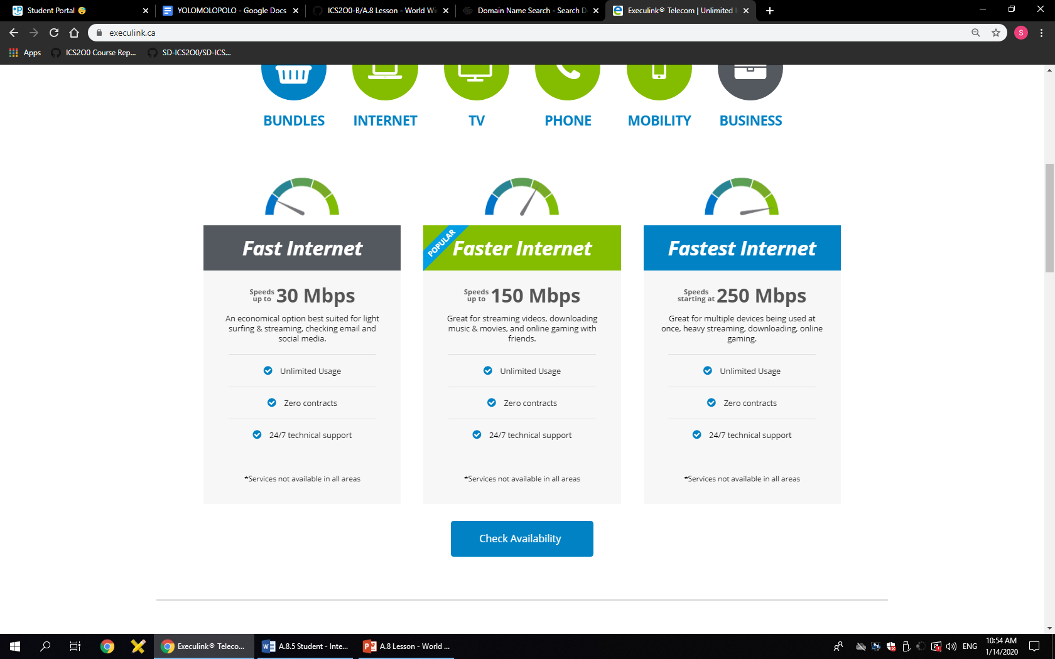

1. **What business packages do they provide?**
   1. **Bandwidth Speed (both upload & download)**
   2. **Data Limits (and cost for exceeding limits)**
   3. **Connection Technologies (e.g. cable, WiFi, DSL, etc.)**

**DSL**

DSL is an affordable High Speed Internet solution for your business that has the capabilities you need. From a standard DSL connection to a solution tailored to your business, we’ll customize a solution to suit your business’ unique situation.

Up to 16 Mbps Up to 1 Mbps Unlimited

Other Details:

* Wifi options available
* Capable of supporting most applications for mixed voice and data
* Email addresses with Spam and Virus protection
* Can be used in conjunction with Multi-Link and Hybrid Bonded Internet solution

**Cable**

A no-nonsense High Speed Internet service that uses Coaxial Cable to deliver a fast cost-effective connection. Depending on facilities it can give a higher downstream and upstream connection than standard DSL Internet, allowing more options for your business’ use of cloud-based applications.

Up to 250 Mbps Up to 50 Mbps Unlimited

Other Details:

* Can support higher bandwidth web uses such as cloud-based applications, VPN access, video streaming and file sharing.
* Static IP options available

**VDSL**

This service lets you take advantage of blazing fast speeds over a single phone line or dry loop. The heavier bandwidth is perfect for those with heavy usage demands. Businesses that want to expand to cloud services (SaaS), large file transfers, web-based database applications and VoIP services will appreciate the higher upstream speeds.

Up to 50 Mbps Up to 10 Mbps Unlimited

Other Details:

* Wifi options available
* Capable of supporting most applications for mixed voice and data
* Email addresses with Spam and Virus protection
* Can be used in conjunction with Multi-Link and Hybrid Bonded Internet solutions

**Multi-Link**

Multi-link is a cost-efficient, customized solution that allows for faster download and upload speeds, without a significant added cost. This solution is created by bonding two to four DSL lines together, allowing businesses to take advantage of increased bandwidth and reliability. In the rare occurrence that one DSL line goes down, the others will continue to function.

Up to 48 Mbps Up to 30 Mbps Unlimited

Other Details:

* Bonded Multi-link (MLPPP) DSL connection
* Execulink provided hardware and installation
* Email addresses with Spam and Virus protection
* Customized, cost efficient way to get increased bandwidth
* Static IP options available

**Hybrid Bonded**

Hybrid Bonded Internet improves network resilience and performance by bonding the bandwidth of multiple connections. The system splits the data from each application into its smallest possible component and spreads it across your bonded lines to maximize speed.

Up to 200 Mbps Up to 200 Mbps Unlimited

Other Details:

* Can support higher bandwidth web uses such as cloud-based applications, VPN access, video streaming and file sharing
* Static IP options available
* Can aggregate third party internet service or even LTE Cellular data with Execulink Internet services

**Fibre Internet**

This Internet solution is ideal for those businesses who have applications that require low latency and high upstream bandwidth such as large data back-ups and sensitive voice and video. Execulink Telecom offers a TLS (Transparent Local Area Network Service) to give you the ability to connect your remote offices directly to your head office for one large, securely connected network.

Up to 1000 Mbps Up to 1000 Mbps Unlimited

Other Details:

* Symmetrical speed (download and upload are equal)
* Reliability backed by Service Level Obligation
* Can be provisioned with QoS to provide voice or video traffic priority
* Options for automatic failover to DSL or cellular

1. **What extra security services do they provide? (e.g. Anti-Spam & Virus scanning, Firewall Protection)**

Yes. Execulink Telecom’s network is designed to prevent unauthorized access. In addition, Execulink’s email service also comes with free SpamGuard and VirusGuard protection to scan all inbound emails sent to an Execulink email account. Despite all of the measures taken to secure our network and protect your connection, your computer still needs anti-virus protection, a basic firewall or router, and protection against malware.

Our My Execulink is configured to verify passwords are secure against dictionary and brute force attacks when being added or changed.

1. **What other services do they provide? (e.g. Digital Phone, Voice over IP (VoIP), Television)**

**Phone**

* 7 Free calling features
* Call Display included
* Call Waiting included
* Affordable Long Distance options
* Affordable Voicemail options

**TV**

* **25+ Channels to Start**
  + The Starter Pack comes with 25+ channels. A perfect base to build your Link TV service on.
* **Variety of HD Programming**
  + We have tons of HD channels to choose from.
* **Affordable Options**
  + Add as much or as little as you want - your TV channel package is up to you!
* **Personalized**
  + Customize your service with Theme Packs, Pick Packs, Single Pick and Cloud DVR options!
* **VOD & PPV**
  + Enjoy even more benefits like Video on Demand and Pay-Per-View options.
* **Catch-Up TV**
  + Available on most channels, the Catch-Up TV feature lets you watch a program up to 24-hours after it originally aired!
* **5 Hours of Cloud DVR**
  + Enjoy 5 hours of Cloud DVR recording with the ability to pause, record, rewind and restart your program.
* **Virtual Set-Top Box**
  + Our exclusive Virtual Set-Top Box lets you watch live TV on your phone or tablet!

**Mobility**

* Packages starting at $15
* No contracts
* Unlimited texting
* Free Caller ID, Call Waiting & Call Forwarding
* Free 3-Way Calling
* Add Voicemail for only $3/month
* Add another user to your package and save!